**I Can Win**

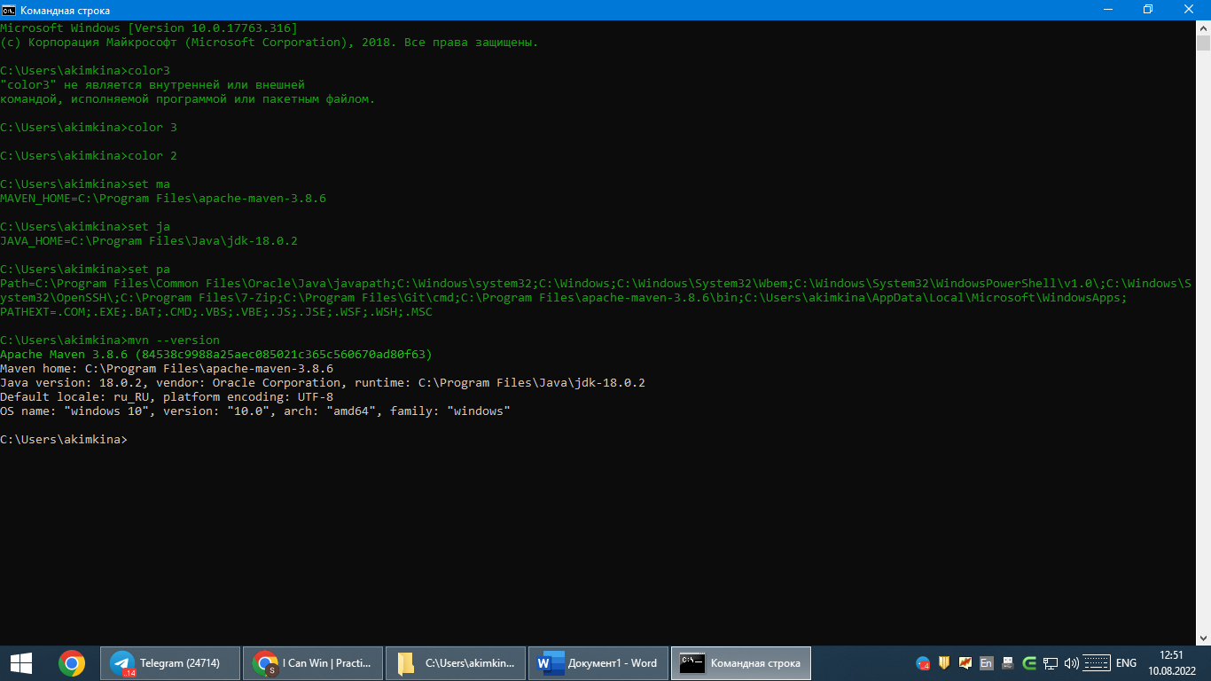1. Install Maven and make sure it works.

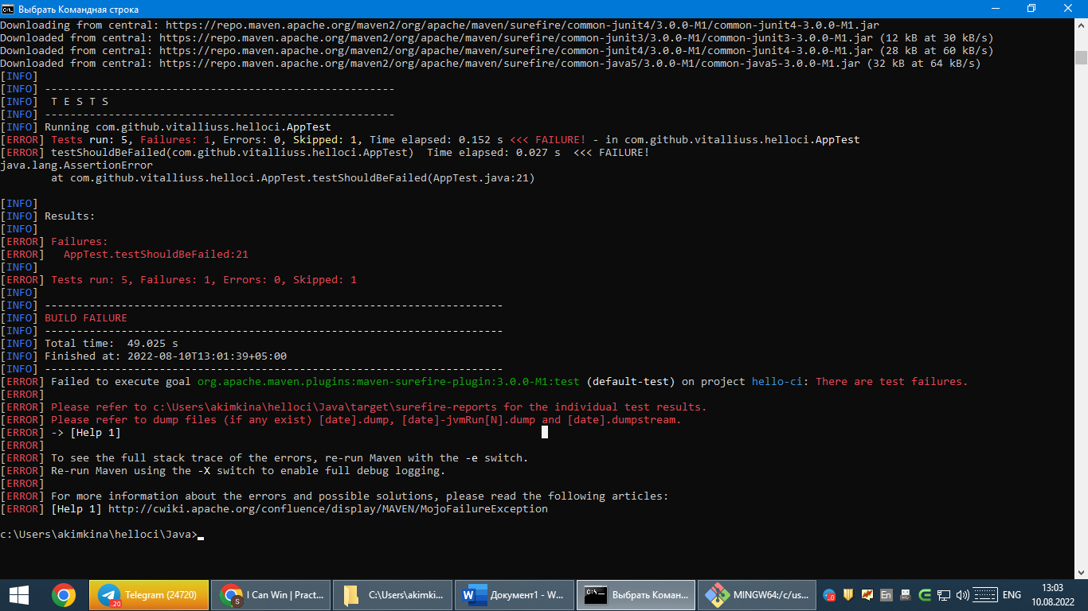2. Download the test project from here https://github.com/vitalliuss/helloci/tree/master/Java and collect it with Maven using the test target.

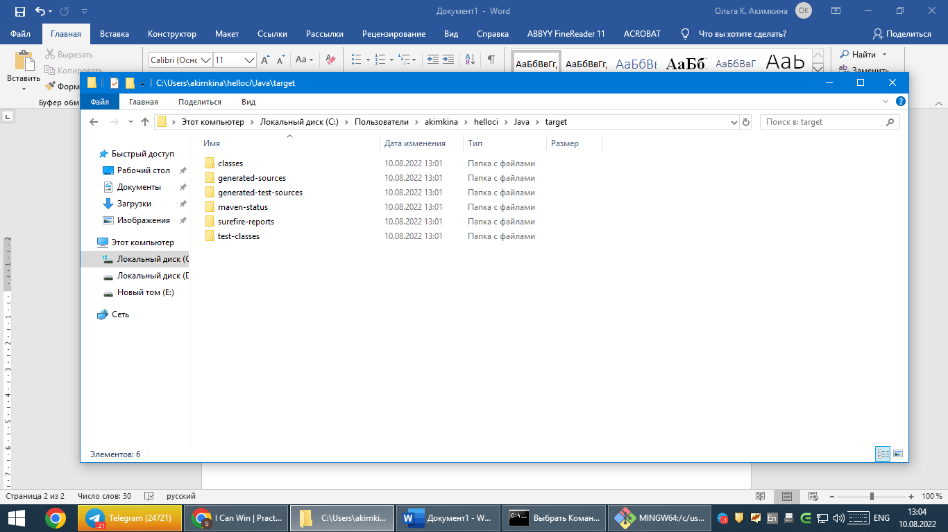**Test target**

3. Find the junit libraries in the folder c: \ Users \ User_Name \ .m2 \ repository \  and look at the date when the files were created.

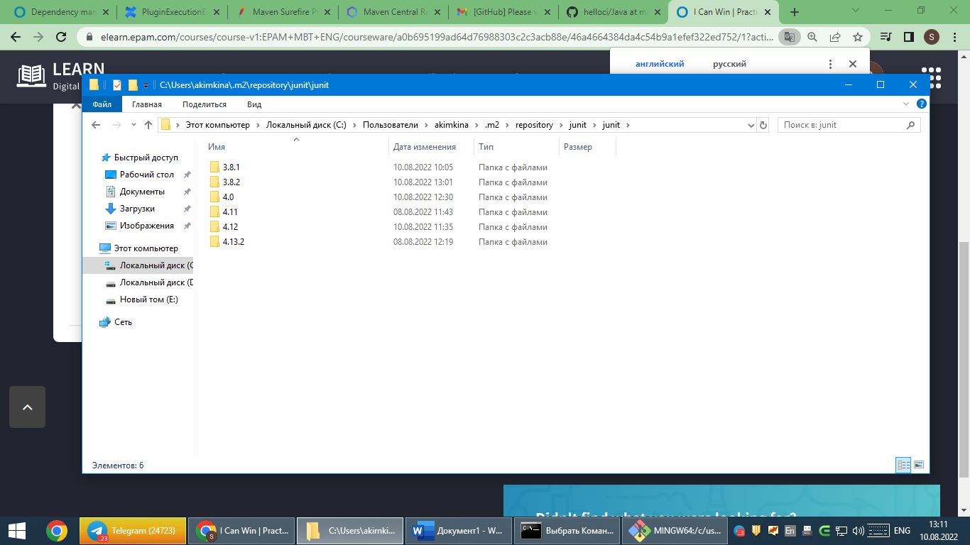

4. Change the junit version in the file pom.xml from 4.12 to 4.11 and collect the project again. Make sure the new version of the library has been added to .m2 / repository

**Done**

